Universidad Politécnica de Valencia

Escuela Técnica Superior de Ingeniería Informática

Statistical Study of the

StackOverflow’s Survey 2022

for the Iberian Peninsula.

Author: Rodríguez Díaz, Gabriel  
Tutor: Zarzo Castelló, Manuel

**Discrete and continuous distributions**

**17.1 Simulate a Poisson variable with the same average as “YearsCode”. Place the graphic of the density function of the new variable and the Histogram for “YearsCode”. Get conclusions from the graphics.**

Since the only discrete variables are not suitable for this kind of analysis, the Poisson variable method was chosen for this exercise.

The average value for the variable **YearsCode** is 14,2388663968. So, we truncate it to get the value for Poisson λ**=14,238.**

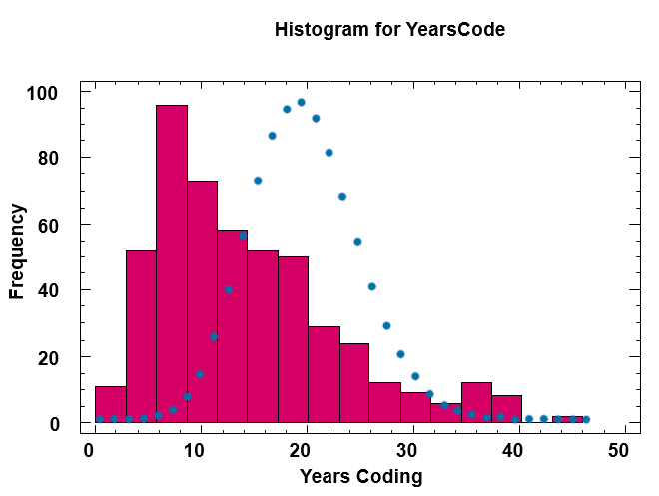

PICTURE 23: Poisson Mass/Density function with Histogram graphic for YearsCode variable

As we can see, the data does not fit a Poisson distribution. The data is positively skewed. That skewness prevents the YearsCode variable from following this kind of distribution. If the data taken was normal it would be possible to approximate Poisson to a Normal distribution and make it fit with different methods.

**17.2 Take a continuous variable and make a new one using $\frac{20*(X-min)}{max}$ and round the results. Finally, answer the indicated questions.**

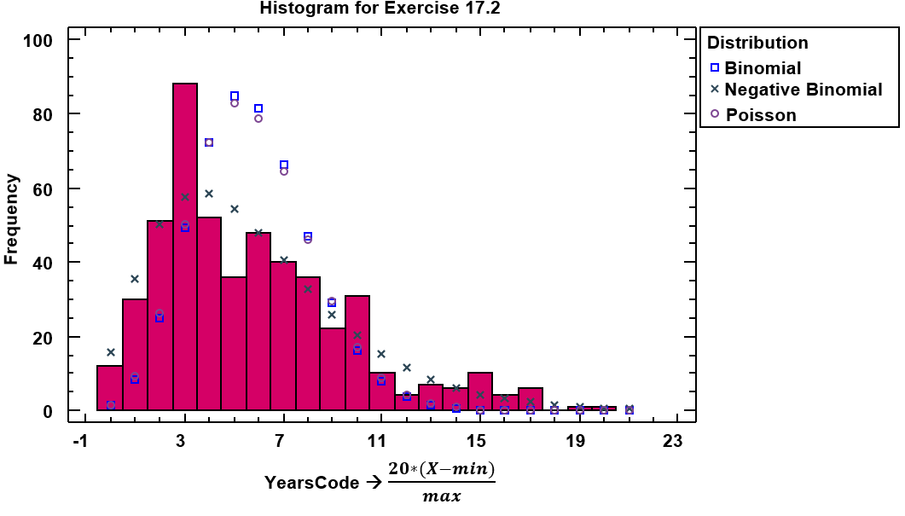

PICTURE 24: Different distributions compared with the histogram of the variable modified using the above formula

As we can see, none of the variables that were reviewed in class fit the histogram. Nevertheless, the Negative Binomial or the Pascal distribution fits more or less if we do not focus much on that extreme value on the left.

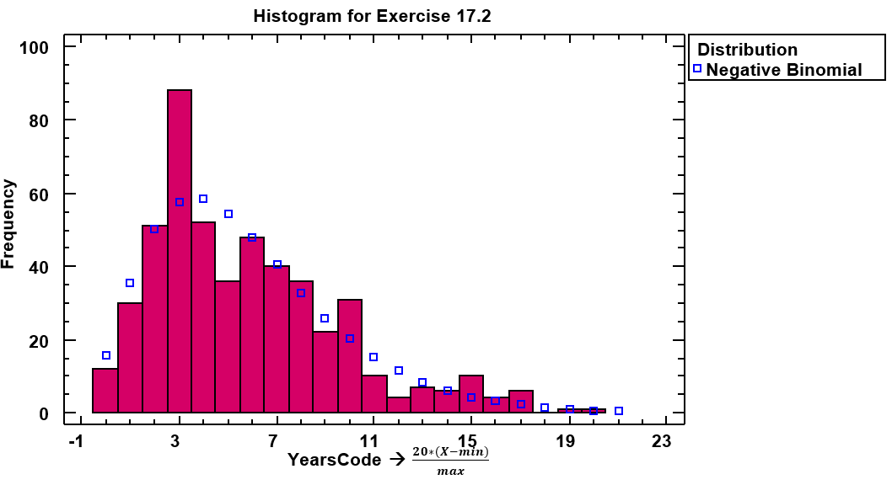

PICTURE 25: Negative Binomial compared with the histogram of the variable modified using the above formula

**18.1 For two continuous variables whose distribution is not normal, study the best fitting model of distribution. Place the graphic and discuss the conclusions.**

The chosen variables are YearsCode and YearsCodePro. Since they are more or less similar, it is interesting to appreciate the differences between both.

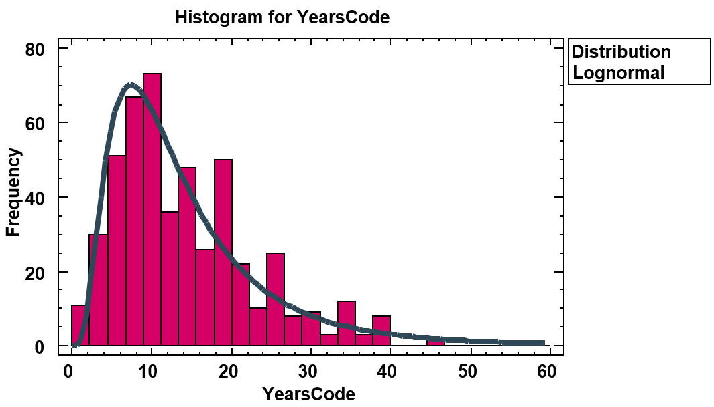

PICTURE 26: Histogram of YearsCode vs Lognormal distribution

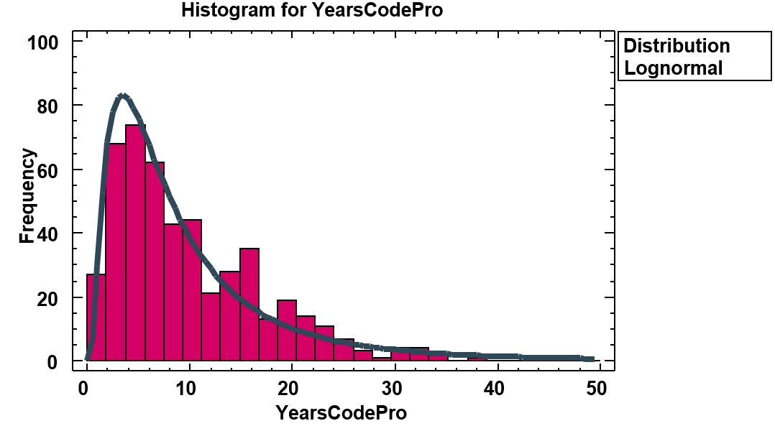

PICTURE 26: Histogram of YearsCodePro vs Lognormal distribution

Clearly, both distributions fit properly into the lognormal distribution. It is important to remark that in the YearsCodePro distribution there are not many extreme values, which may make this variable even better than YearsCode.

We can also note, that the extreme values tend to concentrate in round values such as 10, 15 or 20. This may happen because people tend to answer this kind of numbers when they are not sure of the exact value or they are very close to these certain values.

|  |  |  |
| --- | --- | --- |
|  | **YearsCode** | **YearsCodePro** |
| **Media** | 14,5808 | 10,3679 |
| **Est. Dev.** | 11,0852 | 10,8424 |
| **Log. Media** | 2,45163 | 1,96926 |
| **Log. Est. Dev.** | 0,675393 | 0,859592 |

TABLE 11: Parameters for each of the studied variables

The Kolmogorov-Smirnov test is a statistical technique used to determine whether a sample of data follows a given distribution.

**DMAS** and **DMENOS** represent the maximum positive and negative discrepancies between the two cumulative distribution functions. On the other hand, **DN** represents the test statistic, which is calculated as the maximum absolute difference between **DMAS** and **DMENOS**.

Finally, the P-Value provides a quantitative measure of the strength of evidence against the null hypothesis.

For this case, the Kolmogorov-Smirnov test, shows that the Lognormal distribution fits more or less the data. If we compare it, for instance with the triangular, these values are higher since triangular would have a P-Value of 0.

|  |  |  |
| --- | --- | --- |
|  | **YearsCode** | **YearsCodePro** |
| **DMAS** | 0,0341079 | 0,0579893 |
| **DMENOS** | 0,0667972 | 0,0812606 |
| **DN** | 0,0667972 | 0,0812606 |
| **P-Value** | **0,0243512** | **0,00348525** |

TABLE 11: Kolmogorov-Smirnov values for each of the studied variables

As we can see, the P-Values are quite low. This kind of tests are very interesting, because at first sight YearsCodePro seemed to fit better, but Kolmogorov-Smirnov is the mathematical proof that it was not like that. YearsCodePro is closer to zero than YearsCode.

**19. For two continuous variables with assymetric positive distribution, study if any transformation is able to normaliza the data. Also, add the Normal Probabilistic Plot.**

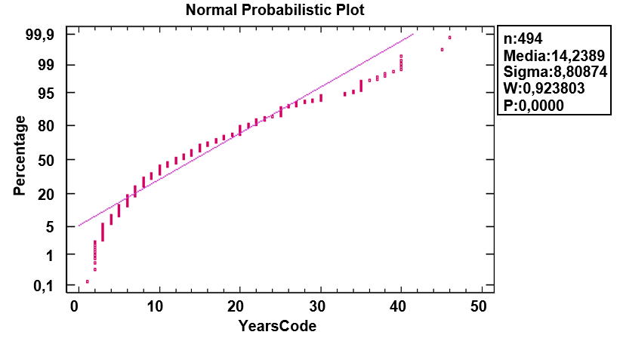

PICTURE 27: Normal Probabilistic Plot for YearsCode

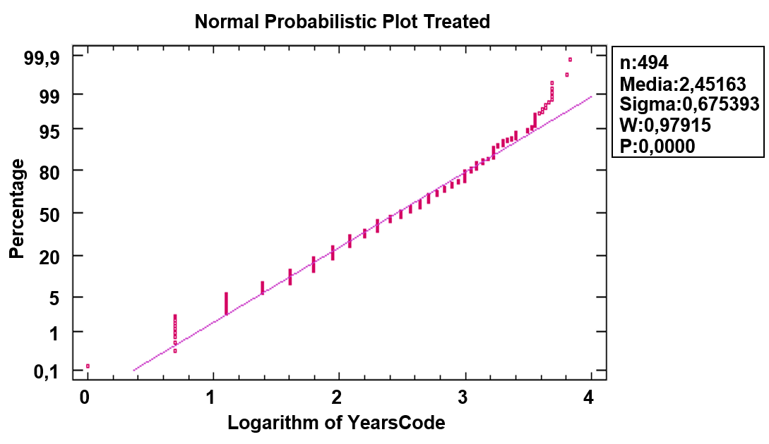

PICTURE 28: Normal Probabilistic Plot for YearsCode with logarithm applied

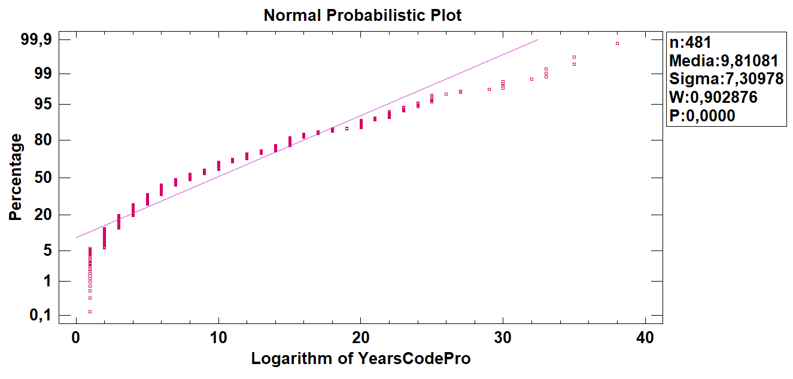

PICTURE 29: Normal Probabilistic Plot for YearsCodePro with logarithm applied

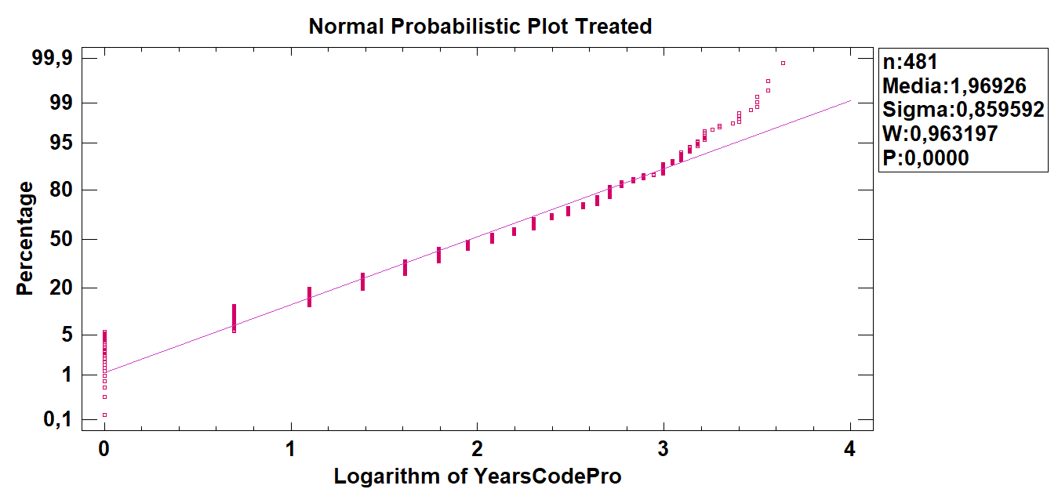

PICTURE 30: Normal Probabilistic Plot for YearsCodePro with logarithm applied

The transformation chosen for both cases was the logarithmic one, since both were positively skewed.

In both cases, no transformation was successful. A possible explanation could be that the IT sector is not as consolidated as others. Many years ago, people used to study other engineerings and that is why they know how to program but they are not programmers by profession.

Also, the increasing demanding in the sector lead that many people started studying coding even if they already have degrees in other fields. That may explain the skewness of the graphic.

In my opinion, as the offer and demanding in the labor maket start stabilizing in the future, the tendency will be a normalization of this kind of data.

**19. Which of the variables follows a reasonably normal distribution? In case there is not any, argue the reasons.**

As it was stated, previously in this project, all the variables are quite skewed and none can be considered as normal.

The reasons for YearsCode and YearsCodePro are explained in the point of **18** this project.

Now, for the variable Salary, which can also be analyzed, the reason is simply how the labor market works, among other reasons.

If we talk about high salaries, in the IT sector you can earn salaries higher than 50000€ or even 100000€

When you are a highly skilled engineer with many years of experience, the lack of profiles like yours is a very good advantage while you are negociating a salary. There is an increasing demand of programmers with a low offer of professionals.

Also many people work for other countries with much higher income levels compared to Spain and Portugal.

On the other hand, if we take the low tail of the distribution, we can argue that a lot of people are starting to study Computer Science (So, they start with lower salaries). As we can see, for example, here at the ETSINF UPV, the Computer Science degree is the most demanded of the university and the cut-off marks for these kind of degrees have been increasing a lot.

Another reason may be that the medium salary in Portugal was around 23.9% lower than Spain’s in 2022 (Data from Datosmacro.expansion.com). This means that Portugal (Or Spain) is probably skewing the data.

This last hypothesis could be studied in the future with the current dataset.

**20. Generate 100 random values of N(m=15,** **=4) and 100 more with N(m=3,** **=3). Generate a new variable by summing the values by pairs.**

**20.1 Describe the process**

Firstable, I created the distributions in Statgraphics.

*Gráficos > Distribuciones de probabilidad > Normal > Insert the distributions*

Then I generated the data using this button  and moved it to Excel.

Finally, I computed the sum by pairs in Excel with the function *=ColA+ColB* and moved it back to a new column in Statgraphics.

**20.2 Based on asymmetry coefficient and Kurtosis, check if the variable is adjusted to a Normal Distribution.**

|  |  |
| --- | --- |
| **Standarized Skewness** | **0,404565** |
| **Standarized Kurtosis** | **-0.7497** |

TABLE 12: Standarized Skewness and Standarized Kurtosis for SUMA.

Based on the Skewness and Kurtosis values alone, the distribution appears to deviate from normality, primarily due to the negative Kurtosis value. However, the skewness is not strongly positive, so the deviation from normality may not be significant.

**20.3 Calculate the mean and the standard deviation for SUMA.**

|  |  |
| --- | --- |
| **Mean** | **18,3215** |
| **Standard Deviation** | **5,25152** |

TABLE 13: Mean and Standard Deviation for SUMA.

**20.4 Using theoretical calculus, which would be the expected mean and standard deviation?**

Being m1 the average for N(15,4) and m2 the average for N(3,3)

SUMA Average = $\frac{m1+m2}{2}$ = 9

Being ** **the stdev for N(15,4) and ** **the stdev for N(3,3)

Standard Deviation ** **= == =

**20.5 Why do the theoretical values do not coincide with the observed ones?**

That is because we are generating random numbers for both of the normal distributions and saving them. Since we are only taking 100 random values that follow that kind of distribution, the average and the standard deviation are never going to be totally accurate. For instance, for the first normal distribution with average 15 and standard deviation 4 we obtain values of **18,3215** and **5,25152** respectively. That is because 100 values are not enough to obtain an accurate distribution. If we increase the number of values from 100 to 10000, then we obtain an average of **14,9885** and a standard deviation of **4,00597** for the first distribution, which are much more accurate. The parameters of the variable sum computed theoretically do not take into account the random values that we are generating, but Statgraphics does. That is why they do not match how we would expect them to. However, the more random values you generate, the more accurate they become. Since in this case we only have 100 values it is normal to get an average and standard deviation that are only an approximation of the theoretical ones.

**Note:** For the computations with 10000 values, I did the following:

I created a new column called “Random1 10k” on Statgraphics. Afterwards, I went to Excel where I used the following formula: *=DISTR.NORM.INV(ALEATORIO();15;4)*

I generated the 10000 registers and moved them to Statgraphics, where I computed the proper average and standard deviation.